Pipes in Angular

There are two types of pipes

1. Inbuilt-pipes
2. Custom Pipes

**1. Inbuilt Pipes**

Prepare new app

* ng new pipeapp

Generate component

* ng g c pipe-demo

goto> pipe-demo.component.ts file

import { Component, OnInit } from '@angular/core';

@Component({

  selector: 'app-pipe-demo',

  templateUrl: './pipe-demo.component.html',

  styleUrls: ['./pipe-demo.component.css']

})

export class PipeDemoComponent implements OnInit {

  constructor() { }

  ngOnInit(): void {

  }

  name:string ="My Name is Nikunj And i am Java FSD Trainer";

  pi:number=3.1415927;

  a=0.12345;

  b=9876.5432;

  today=new Date();

  object={name:"nikunj",email:"test@gmail.com",address:"mumbai,india"};

}

Goto> pipe-demo. Component.html file

<h1>Inbuilt PIPES</h1>

<hr>

<p><b>UPPERCASE DEMO: </b>{{name|uppercase}}</p>

<p><b>lower case demo: </b>{{name|lowercase}}</p>

<hr>

<h2>Number pipes</h2>

<p><b>pi: </b>{{pi|number :'5.5-5'}}</p>

<p><b>pi: </b>{{pi|number :'.3-3'}}</p>

<p><b>pi: </b>{{pi|number :'.10-10'}}</p>

<hr>

<h2>Currency Pipes</h2>

<p><b>USD </b>{{a|currency :'USD':true: '3.3-3'}}</p>

<p><b>USD </b>{{a|currency :'USD':false: '3.3-3'}}</p>

<p><b>EURO </b>{{a|currency :'EURO':false}}</p>

<p><b>INR </b>{{a|currency :'INR':true: '5.4-4'}}</p>

<hr>

<h2>Date pipes</h2>

<p><b>Today is:  </b>{{today}}</p>

<p><b>Today is:  </b>{{today | date}}</p>

<p><b>Today is:  </b>{{today | date :'dd/MM/yyyy'}}</p>

<hr>

<h2>JSON PIPE DEMO</h2>

<p><b>Without JSON Pipe  </b>{{object}}</p>

<p><b>With JSON Pipe  </b>{{object | json}}</p>

Goto to app.component.html file and add selector tag of pipe-demo

<h1>Pipes In Angular</h1>

<app-pipe-demo></app-pipe-demo>

Save and check the output

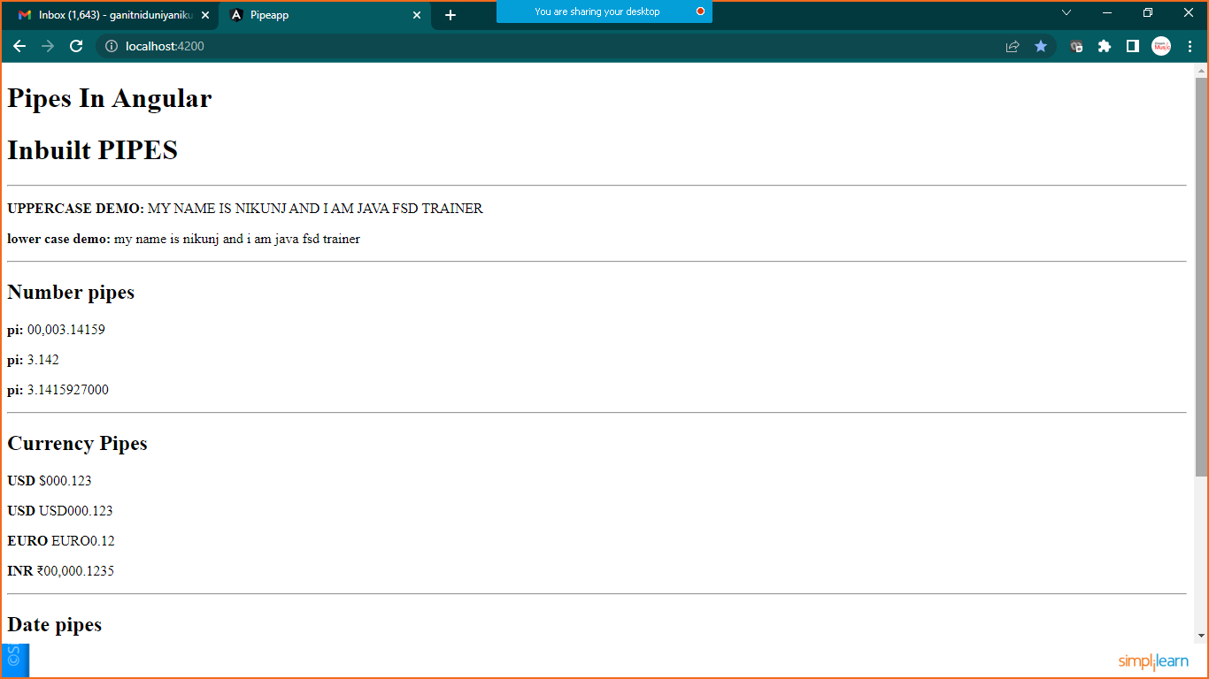

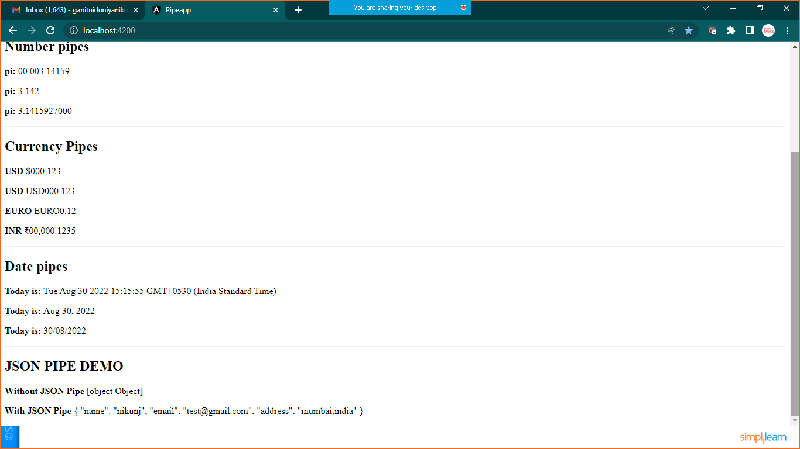

2.Custom Pipes

Goto >**pipe-demo.component.ts** and add below code

  //custom pipes

  cust:string ="welcome to the world of CustomPipes"

**now >right click on app>new file >CustomPipes.ts**

import { Pipe, PipeTransform } from "@angular/core";

@Pipe({name:'changeString'})

export class CustomPipes implements PipeTransform{

    transform(value: string,character:string) {

        return value.split(character).join("-");

    }

}

Now register this file in **app.module.ts**

import { NgModule } from '@angular/core';

import { BrowserModule } from '@angular/platform-browser';

import { AppRoutingModule } from './app-routing.module';

import { AppComponent } from './app.component';

import { CustomPipes } from './CustomPipe';

import { PipeDemoComponent } from './pipe-demo/pipe-demo.component';

@NgModule({

  declarations: [

    AppComponent,

    PipeDemoComponent,

    CustomPipes

  ],

  imports: [

    BrowserModule,

    AppRoutingModule

  ],

  providers: [],

  bootstrap: [AppComponent]

})

export class AppModule { }

goto>**pipe-demo.component.html**

<hr>

<h2>Custom  Pipe Demo</h2>

<p><b>Custom Pipe:   </b>{{cust| changeString:' '}}</p>

<p><b>Inbuilt and Custom Pipe:   </b>{{cust|uppercase|changeString:' '}}</p>

Save and check the out put

